Saint Cecilias College

OBJECT ORIENTED PROGRAMMING 2(PF205)

Smart Scan

BSIT 2-B

Jhon Leo Welliam C. Entac

SMART SCAN revolutionizes attendance tracking at Saint Cecilia's by utilizing RFID technology. This innovative system offers a streamlined approach to monitor the presence of students, teachers, and staff, ensuring precision and reliability. By automating the attendance process, SMART SCAN optimizes administrative tasks and promotes a more efficient educational environment.

The integration of RFID technology allows for quick and accurate logging of attendance data as individuals enter and exit designated areas. Each participant is equipped with an RFID card, which is scanned upon their arrival and departure. This eliminates the need for manual attendance taking, reducing errors and saving valuable time for both students and staff.

With SMART SCAN, Saint Cecilia's can maintain real-time attendance records, which are easily accessible for administrative review and reporting. The system also enhances security by providing an up-to-date log of all individuals on campus, contributing to a safer school environment.

Furthermore, the data collected can be analyzed to identify patterns in attendance, enabling the administration to address issues such as chronic absenteeism more effectively. This proactive approach supports student engagement and academic performance.

In conclusion, SMART SCAN not only modernizes the attendance tracking process at Saint Cecilia's but also reinforces the institution's commitment to leveraging technology to improve operational efficiency and educational outcomes.

GUI GUIDE

It Exits the System

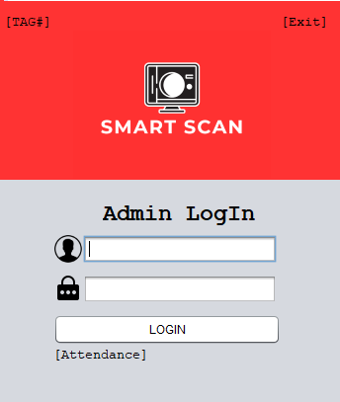

If you forgot your Password or User just Scan your ID(RFID) to Log In

Redirects to Attendance Window

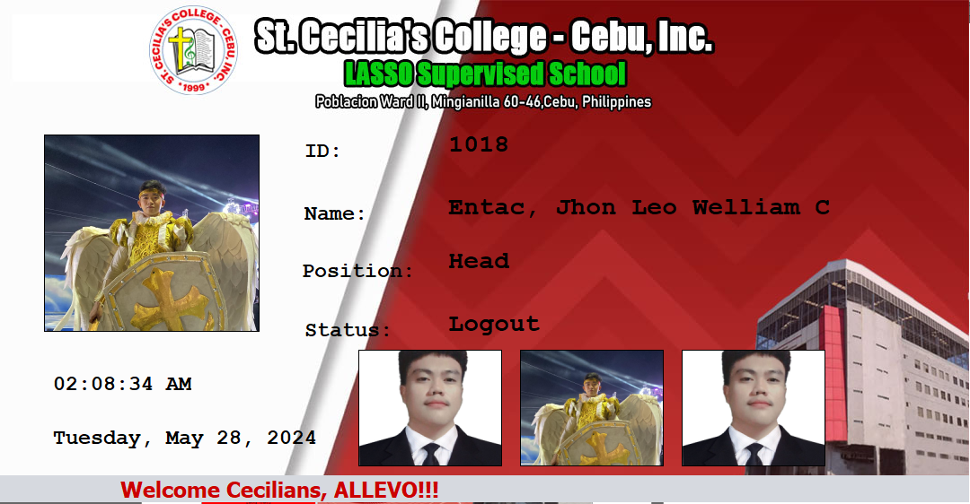**Attendance Window**

**DASHBOARD for ADMIN/SUPER ADMIN**

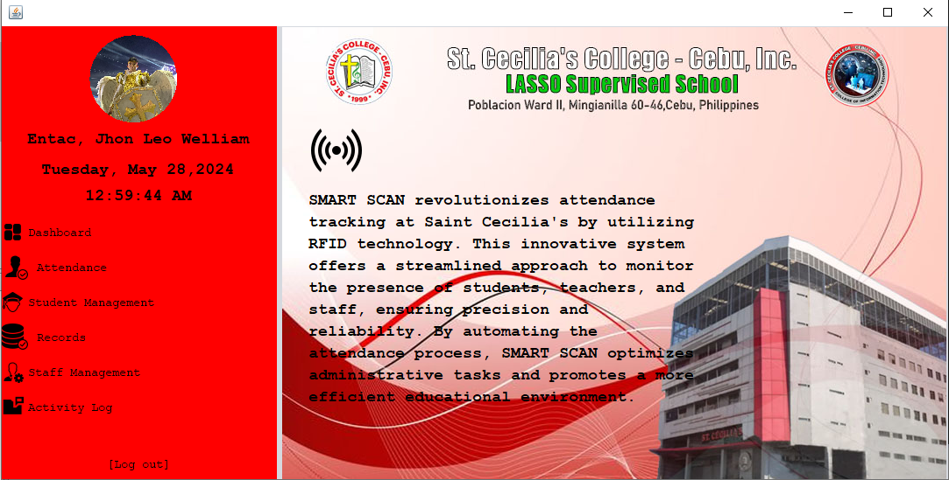

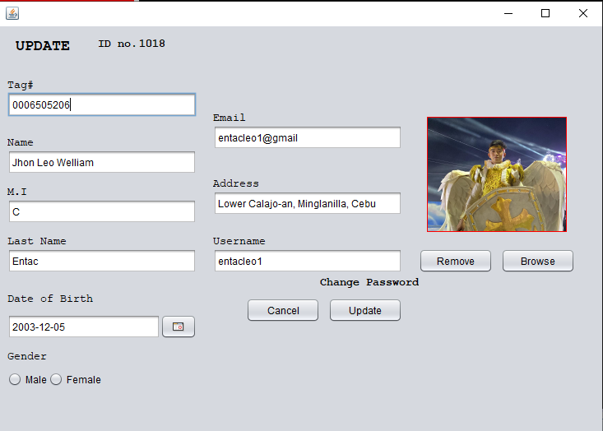

Direct you to User Update

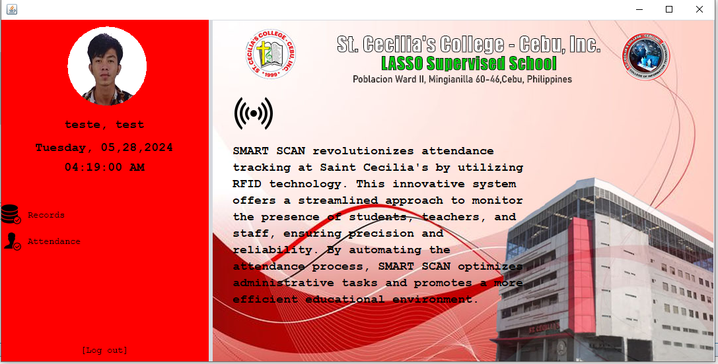**DASHBOARD for USER/Teachers**

**Manage Grade and Section**

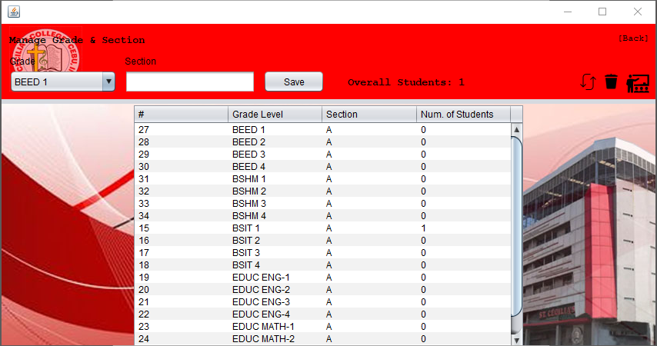**It is Where you Add/Delete Sections**

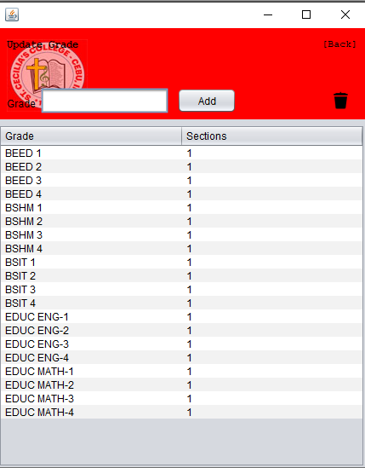

**Student Master List**

**It is Where you can View All of the Students and Where you can Add, Delete, Update Students**

Directs you to Manage Grade and Section

And Archive Window

Update Students in the Selected row

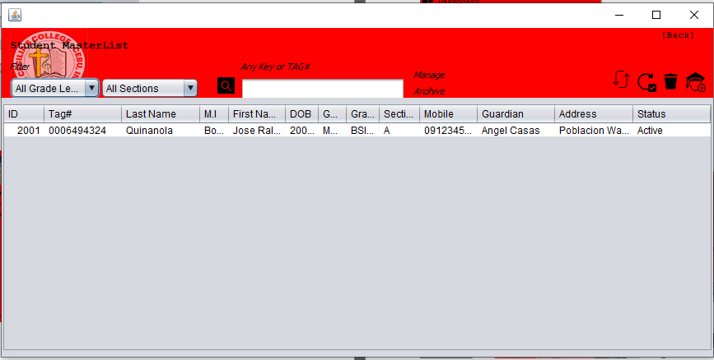

**Note:**

**Manage and Archive are only Visible When you’re a Super Admin**

Delete Student but not Totally deleted it will go to the archive table

It Is Where You Add Students or Update Students After Pressing Update Button

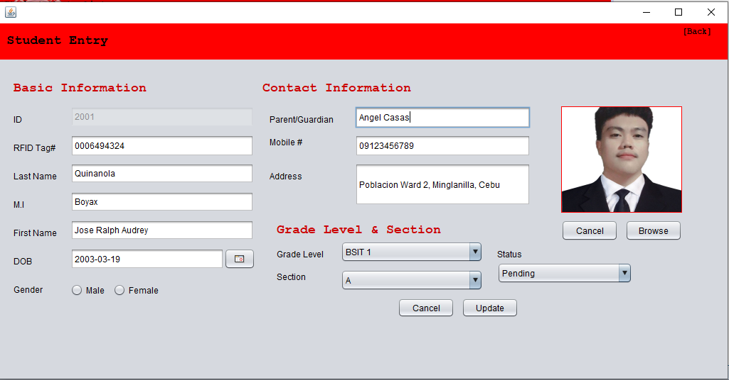

**Note:**

**Status Option is only visible When you’re a Super Admin**

**Archives**

**It is where you Retrieve or Permanently Delete the Student/Staff you Deleted**

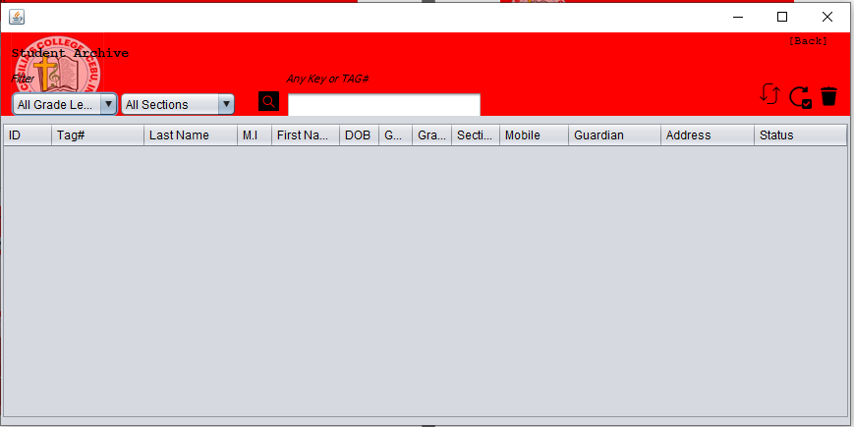**Student Archive**

**Staff Archives**

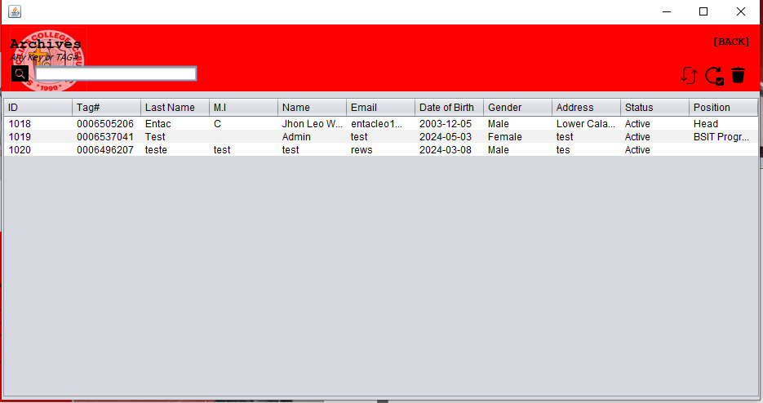

**Account Management**

**It is Where you can View All of the Accounts/Staff and Where you can Add, Delete, Update**

Update Staffs in the Selected row

Archive Window

**Note:**

**Archive are only Visible When you’re a Super Admin**

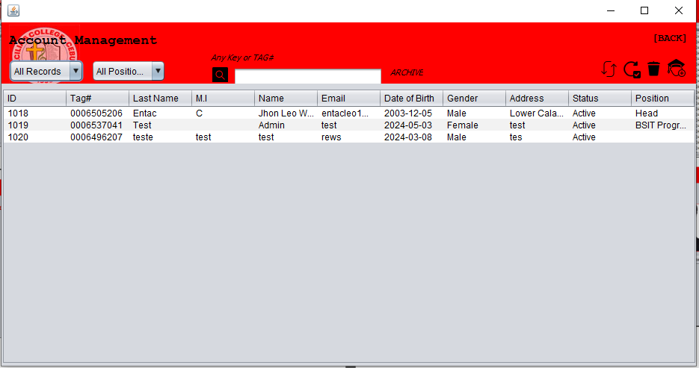

Delete Staffs but not Totally deleted it will go to the archive table

It Is Where You Add Students or Update Students After Pressing Update Button

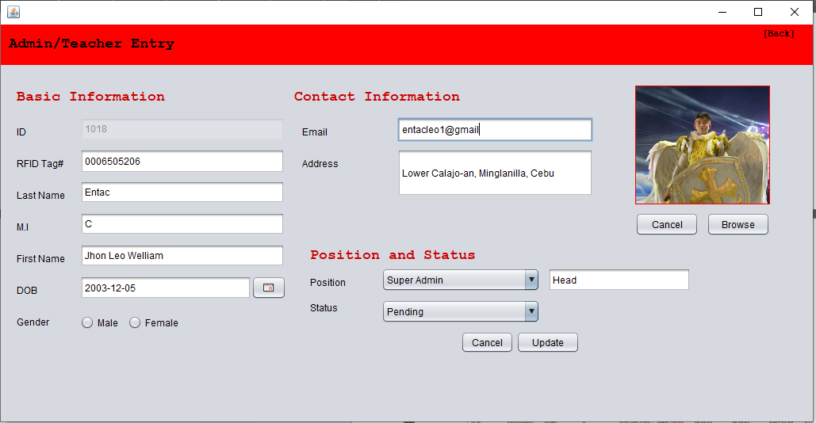

**Note:**

**Status Option is only visible When you’re a Super Admin**

**Records**

**It is Where you View you the Student/Staffs Attendances**

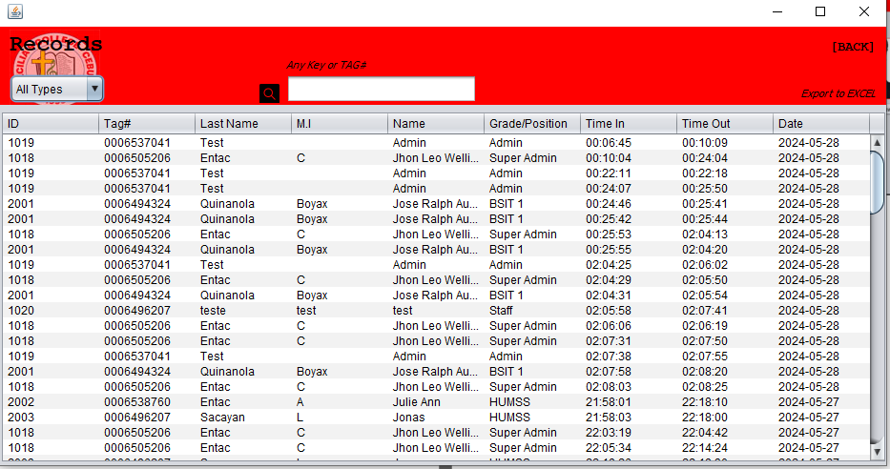

Export To Excel

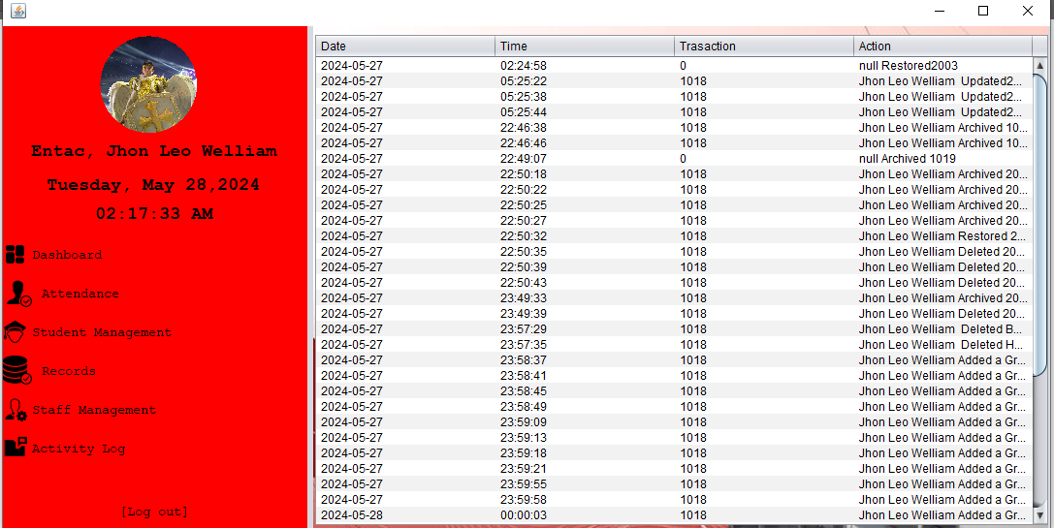**Activity Logs**